**David Warner (1920-1982)**

Alderman Willoughby Council (1962-74, Mayor 1973-74)

Artarmon Progress Association

Willoughby District Historical . Society

Presbyterian Church

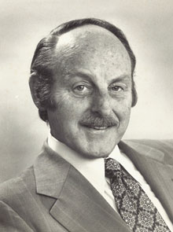

Born in 1920, David Warner lived in the same house in Tindale Avenue, Artarmon, for 61 years. A cartographer by profession, David became General Manager of Gregory’s Maps. He was active in the Artarmon Presbyterian Church and joined the Artarmon Progress Association in 1949. The association urged him to run for Willoughby Council in 1969. He was Deputy Mayor in 1971-72 and won a ballot against Bob Dougherty in September 1972 to become Mayor. He served two terms as Mayor, but did not contest the 1974 council elections. He and his wife, Janette, moved to Armidale in 1982 to be near their children.

As Mayor, David Warner facilitated the public meeting that led to the establishment of the **Willoughby District Historical Society** in February 1974. He was the society’s inaugural Vice-Patron and continued in the position until December 1982. Following David’s death, Janette donated his photographs, ephemera and documents to the Willoughby Museum.

The collection includes the prints of the Depression era photographs taken by Willoughby Council officers on which David recorded the location, activity and specific date each image was taken, key information that was unavailable with the negatives held by Willoughby City Library.

David and his wife Janette were joint Willoughby Citizens of the Year in 1982 for services to local government and the community.

David is a great grandson of Robert Forsyth (1848)