Our Own FORSYTH Saga

From the romantic images of wild Scottish highlands, misty glens, bagpipes, tartans and kilted warriors we find our own Forsyth family in Dunfermline, in Fife, just north of Edinburgh in the mid 18th century, living the lives of urban working people with families to house and feed.
Dunfermline’s recorded history stretches back for nearly a thousand years, during which the town has known both prosperity and decline. In its early days it was a favourite residence of royalty and a great religious and pilgrimage centre. After the Reformation of 1560 it suffered two centuries of decline, accelerated by a disastrous fire in 1624 which destroyed much of the town. Recovery began in the eighteenth century with the advent of the damask linen-weaving business and reached its climax in the nineteenth century when many other industries came to the town. It also shared in the prosperity brought to the region by coal mining.
In the 1800’s Dunfermline was a market town, with a corn market each Tuesday and a weekly Friday market to sell butter, cheese and eggs. A spring to the north-east of the town supplied water through conduits built of stone and lime, and pipes of wood and cast iron, installed in 1797. A filtration system was installed in 1850 however the water supply was far from adequate. Coal was available locally and with the weaving and spinning mills was one of the main employment opportunities. There were 3 iron foundries and five breweries.
There was high child mortality in the parish and before 1833 small children were able to be employed for long hours in factories. The population of Dunfermline was 8,552 when we pick up our Forsyth story in the 1750s but had reached 21,687 one hundred years later in 1851.
About 1742, around the time of the Battle of Culloden, a young man by the name of Walter Forsyth was born, probably in Dunfermline. We don’t know anything more of Walter except that in 1762 he married Helen Blackwood who was born in Dunfermline in 1744 (par. John Blackwood and Helen Crawford). Walter and Helen had 4 children, the youngest of which was William born in 1768, still in Dunfermline. William Forsyth became a baker in Dunfermline and on 16th June, 1791, married Ann Anderson.
William and Ann Forsyth had a large family:

Walter (born 1792), Cicel (1794), Helen (1796), Ann (1797), James (1799, must have died before 1807), William (1802), John (1803), James (1807), Charles (1809).
Most of the bread baked by William Forsyth in Dunfermline would have been of the heavy rye or barley type with oats, eaten as porridge, being the staple cereal. Very little bread would have been made with wheat (which gives the highest quality bread) as it was very hard to grow in Scotland due to the damp climate. At the beginning of the 19th century the Napoleonic wars stopped the import of European wheat but when peace did return the Corn Laws were put in place. These Laws were import tariffs designed to protect UK corn (grain and cereal crops) against the cheaper foreign imports. It wasn’t until the repeal of the Corn Laws in 1846 that cheap wheat was again available.

Our principal person of interest in this family is John, born 11th November 1803, the 7th of 9 children. His baptism is included in the Old Parochial Registers of Scotland for 18th November, 1803, son of William Forsyth, baker, and Ann Anderson. The witnesses were James Anderson, smith, and John Saunders, baker, probably a relative and a work colleague. (Both of these men are listed on the 1798 Horse Tax Roll as paying 2s duty for 1 working horse each).
John would have grown up in Dunfermline with limited education. He eventually became a blacksmith by being apprenticed to another blacksmith – probably the family member, James Anderson, named on his baptism. The apprenticeship would have started when he was 12-15 and lasted for 5-7 years. He would have received little or no wages, just room and board, and the chance to learn the skills of the trade which were to stand him in good stead in later years. It was a hot and physical job but the blacksmith was a respected member of any community. He was responsible for making the tools of every other craftsman, shoeing horses, the only form of transport, and maintaining all the carriages and wagons.
John was working as a blacksmith in Edinburgh, when he married Janet Adams in St Cuthbert’s Church, Edinburgh, on 27th July 1827. Janet was the daughter of the late John Adams, a weaver, of Glasgow, and his wife Margaret Brown. Janet was living at 41 Melville Street, a grand terrace house in the Georgian Newtown area of Edinburgh. This house was owned by Major-General Sir George Leith, a Baronet, and his wife Lady Albina Leith (“The Scottish Jurist”, 1848, pg 419) so we will assume that Janet was working as a domestic servant for this family. John was living at 42 William Street which even today is a service street directly behind Melville Street on the opposite side to no 41. It is a street of connected garages now that have clearly been converted from stables and coach houses of the 19th century. John would have lived above the stable where he worked maintaining the horses and carriages of the inhabitants of the large houses.
Less than 4 weeks after their marriage John (aged 24) and Janet (‘Jessie’, aged 22) had packed up and boarded the ship “Greenock” for a long trip to New South Wales. The departure of the ship from Leith (the port of Edinburgh) on the 21st August 1827 was announced with just a single line entry in “The Edinburgh Advertiser”. Also travelling on the same ship was Helen Forsyth, John’s sister, and her husband Alexander Lyle Patison* and 4 daughters. It was reported in NSW that Alexander Lyle Patison, an engineer, had been “…brought to NSW to superintend the erection of Robert Cooper’s engine at Black Wattle Bay”. Alexander may have been recruited by the Rev John Dunmore Lang, the creator of the Presbyterian Church in Australia, who travelled between Australia and Scotland several times encouraging migration to NSW in order to increase the number of free skilled workers, and to produce a ‘moral reformation’. The initiative for this brave move to NSW probably began with the Patisons but John and Janet Forsyth may have been eager to escape the wet, cold, crowded conditions of Edinburgh when offered the opportunity of an adventure to a land of promise - made easier by the company of close family members.
*There are various spellings of Patison/Pattison/Paterson used throughout the records – the most consistent one for this family seems to be ‘Patison’ so we will stick with that.
The journey of the Australian Company’s ship, “Greenock”, with Captain Miller at the helm and travelling via Batavia and Hobart took 7 months, reaching Sydney on the 3rd March, 1828. (Which is, incidentally, the birthdate of their great-great-great granddaughter Jacki, 144 years later!) When they arrived in Sydney Janet was 6 months pregnant so coping with that very long sea journey with possible seasickness, morning sickness and homesickness could have seemed like a nightmare. With the 4 Patison girls and the daughters of other families on the ship there were 14 young girls on board. Several of those families disembarked in Hobart and went on to create successful farming ventures in Tasmania.
One can only wonder what John and Janet’s reaction would have been at the first sight of the penal colony of Sydney. Along with their relief at finally reaching land after 7 months they would have been told that the white population of NSW was 36,598 of which 56% were free, and the remainder were convicts. Males made up 75% of the population and 69% were Protestant. The drawing here shows George Street in 1828.
Three months later, on the 15th June 1828, John and Janet’s son, William, was born in Sydney and was christened by the Rev. John Dunmore Lang in the new Scots Church. As the first son he was named for John’s father. In October 1828 when the Census was taken the Forsyth family - John, Janet and baby William - were living in Kent Street with a David Anderson, a sailmaker, his wife Agnes (a freed convict) and family. David had been in NSW since 1816 and was probably related to John’s mother, Ann Anderson. In September 1828 John Forsyth was listed amongst a “List of Petitioners from J.D.Lang and Presbyterians for Subsidy towards a Master of Proposed School,” along with David Anderson and A.L.Patison. (Historical Records of Australia – Series 1 – Vol XIV – pg 397).
The Rev. John Dunmore Lang (1799-1878) was a Scottish Presbyterian clergyman, politician, educationist, immigration organizer, historian, anthropologist, journalist and gaol-bird. He arrived in Sydney in May, 1823 and was the most famous (or notorious) Scot in nineteenth-century Sydney. He set about organising the Presbyterian cause, in which he was later to cause periodical divisions and schisms. After clashing with Governor Brisbane he had to raise private funds to build the first Scots Church which opened in 1826 on Church Hill, York Street. (This historic building was demolished in 1928 to widen York Street for Harbour Bridge Traffic.) He opened a primary school in 1826 and eventually the secondary school, the Australian College. The upright young minister was horrified by the licentiousness of the convict colony and tried various methods to improve colonial morality. He led a colourful and prominent life in NSW, had a large family, owned land and brought many new clergymen to Australia to establish the Presbyterian Church.
There is no record of where John Forsyth was working in that first year in Sydney but Alexander Patison was working for Robert Cooper as an engineer. Robert Cooper was an emancipist (transported for smuggling) who became a prominent business man in Sydney with the erection of several distilleries, a brewery, flour mills and a bakery. Other interests included cedar cutting, the production of gunpowder, the weaving of cloth and building steam ships for the coastal trade. Later he built a mansion in Paddington for his 3rd wife and family called “Juniper Hall”, which still stands today. (He fathered 28 children with 3 wives!)

Sometime early in 1829 our John Forsyth transferred his little family to Parramatta where he began working as an engineer at the Darling Mills. (To be labeled an engineer was presumably a ‘step-up’ from being a blacksmith). This steam-driven flour mill was opened in 1826 and was situated on the (Old) Windsor Road near Broken Back Bridge, a toll gate on the road to Windsor. It was the 1st of its type in Parramatta and gave a great impetus to the growing of grain. Unfortunately the district and climate were not fitted for wheat and the mill was eventually forced to close, to be reopened later as woollen mills. (The site is now occupied by a Dick Smith Electronics store!)
While at Parramatta our next generation John Forsyth (named for his mother’s father) was born to John and Janet on the 7th October, 1829, and was also baptized by the Rev J.D. Lang, on 8th November.

Six months later the family was traumatized by a criminal attack.

Barbarous Outrage Sydney Gazette Tuesday 1 June 1830

On the evening of 23rd ult. As Mr John Forsyth, Engineer at Darling Mills, was returning home from Parramatta a little after 6 o’clock, he was attacked by 4 ruffians armed with bludgeons, who beat him so unmercifully on the head that he has been in a state of insensibility ever since and his life is almost despaired of. A humane individual who happened to pass near the mills almost immediately after the outrage raised him from the ground and he had sufficient strength remaining to walk home and tell his wife that he had been attacked by 4 or 5 men, one of who on his telling them he had only 18 pence replied “You ----, it’s not your money but your life I want”. He had no sooner given this information than he suddenly became insensible, the consequence of the serious injury sustained by the brain by the fracture or depression of the skull and though he has occasionally evinced some degree of recollection for a day or 2 past, and a second or two at a time, he again relapsed into the same state of insensibility immediately thereafter. On Friday afternoon last 2 gentlemen of Sydney who felt an interest in Mr F’s welfare and who had heard of the circumstance accidentally, went to Parramatta and on hearing the particulars of the affair on the spot gave information to the Chief Constable who immediately proceeded to the mills and apprehended the suspected individual. Mr F. and his wife, who have 2 infant children are free emigrants from England (sic) and it is supposed that they provoked the enmity of the wretches who perpetrated this atrocious outrage by their uniform integrity in the service of their employer. If such has been the fact, as the writer of this communication has reason to believe their fidelity has met with a very strange, if not to say, inhumane return.

Fortunately John seems to have recovered from this most serious injury but he could have been left with some severe disabilities. He quickly moved his family back into George Street in the city away from the frequent bushranging and robbery in the Parramatta area.

But this was seemingly the beginning of a series of unhappy events and misfortunes in their lives. In September 1831, a baby girl, Anne Adams Forsyth, was born to John and Janet, and christened by the Rev John McGarvie, but she died 5 days later of ‘severe convulsions’. Anne was named for John’s mother and this strict Scottish naming regimen was to prove very helpful for descendants trying to find the right records amongst multiples of possibilities.

The 1832 Post Office Directory lists a business for John of “Forsyth and Albon”, Smiths, George St, but this partnership couldn’t have been very successful as an advertisement appeared in the “Sydney Gazette” in April of 1832:

The Co-Partnership heretofore subsisting between the undersigned, under the Firm of Forsyth and Albon, as Anchor, Ship, and House Smiths, is this day DISSOLVED by mutual consent. The business will be, in future, carried on by John Forsyth alone, and at the same place as formerly – As witness our hands, this 17th April, 1832.
John Forsyth Richard Albon.

In late 1831 John’s brother-in-law Alexander Lyle Pattison was the engineer in charge of the installation of steam engines for the very first Australian-built paddle steamer, the “William IV”. It was built at Clarence Town by shipwrights Marshall & Lowe for a prominent Sydney businessman, Mr Joseph Grose. Alexander is reported to have ‘greatly improved the functioning of these engines in his Phoenix Foundry in George Street’ before they were taken to Clarence Town to be installed. The William IV was schooner-rigged, built completely of the indigenous ‘flooded gum’ and the launch in January 1832 was a much-heralded event. It was set to revolutionize coastal trading firstly between Sydney and the Hunter and later from as far south as Jervis Bay and north to the Clarence River. John Forsyth and David Anderson were probably also involved in this venture.

The NSW Calendar and Post Office Directory of 1833 lists John Forsyth as a ‘shipsmith’ in Lower George Street and Alexander Patison as a ‘millwright’ in Upper Pitt Street. Obviously their work was centred around the burgeoning ship-building industry.

In May 1833 John Forsyth and Alexander Lyle Paterson were both listed as directors of the Australian Steam Conveyance Company which was set up to build the steamer “Australia” for the Parramatta River trade. Alexander was enthusiastic in his promotion of the steam engine and gave many public lectures on its merits in the Mechanic’s Institute in Sydney.

On 26th March, 1834 the next catastrophe occurred for John and the remaining children when his wife Janet died, aged just 31. Her death notice states that she died ‘of a long and painful illness’ and was buried in the Scots (Sydney) Burial Ground in Devonshire Street. John had a headstone erected there and the inscription was recorded, 100 years later, when it and others were removed to allow for the building of Central Railway Station. The stone was described as ‘upright and fair’ and said:

Anne Adams Forsyth, died 30th September 1831 aged 5 days, also her mother Janet Adams Forsyth, native of Glasgow, Scotland, and wife of John Forsyth, of Sydney, died 26th March 1834.

John had only been in the colony 6 years and had lost 1 and possibly 2 children – and now he was widowed as well, with a 6 year old son to care for. The first born son William must have also died in childhood as no further record has been found of him in later years.

John continued to work on in George Street in Sydney and was assigned a convict, a blacksmith William Fairlie, in 1834. In the Australian Almanac in 1835 he was listed as a ‘shipwright’ and in 1837, but now in Sussex Street, he was again assigned a convict, a whitesmith (a tin smith or polisher). He had 3 assigned convicts at this time – William Morgan, John Powell and Thomas Summers. Where the 8 year old John junior was living at this time is unknown, maybe with Helen, Alexander and family.

In 1837 Alexander Lyle Patison gave up most of his engineering work and decided to try farming in the Shoalhaven area. He negotiated a farming lease with a William Graham at Greenhills, just east of where Nowra now stands, apparently built a house and moved his wife and family of 6 children, 5 girls and 1 boy. From the Colonial Secretary’s records it seems that in January 1838 he also purchased 100 acres, at 15/- an acre, on the Shoalhaven River, slightly west of Nowra.

Less than 6 months later the next calamity befell these families - Alexander was drowned at Kiama, aged 42 years.

Accident: Mr Alexander Lyle Patison, formerly Engineer in Sydney, and latterly residing at Shoalhaven, was unfortunately drowned by the upsetting of a small boat, near Kiama, when on his way to this place. He was an excellent swimmer, but is supposed to have taken the cramp in the water. The master of the vessel in which he had taken his passage from Shoalhaven was also in the boat, but was saved. Mr Patison was considered a proficient in Engineering, and came to the Colony in 1827, to superintend the erection of Mr Robert Cooper’s engine, at Blackwattle Swamp. He had been engaged in many other works of the same kind. An inquest was held by Captain Plunkett and Dr Osborne, and the body was interred on Friday, 1st of June. Mr Patison has left a widow and seven children. His friends and the body of the Engineers in Sydney, it is believed, will take the destitute state of his family into consideration, and alleviate the painful bereavement under which they have been suddenly deprived of a husband and parent.

Sydney Morning Herald, Monday June 11, 1838.

Helen was pregnant at the time of Alexander’s death and their last son, Charles J, was born in early 1839. Helen stayed on to farm in the Shoalhaven and records in an old account book from the Graham estate show that William Graham did not charge Helen any rent at all for 3 six-monthly periods after the tragedy. He also supplied her with a ticket-of-leave man, named Big Mick, to help her with her assigned men.

Two years later in the 1841 census the Patisons were still living in the house leased from William Graham at ‘Green Hills’. There were 11 people living in the house, 10 of whom were ‘free’, and all were Presbyterians. Helen had her remaining 4 daughters (1 had married) and 2 sons with her, Charles was just 2 and Alexander, aged 10, was working as a shepherd. There was also a married ticket-of-leave man (presumably Big Mick) and a single free man working as agricultural labourers, and 2 more tiny children who may have belonged to one of these 2 men. In 1843 Helen appealed to the Colonial Secretary to allow her to lease 640 acres at a spot called Long Point, adjacent to the 100 acre block, with her son-in-law John Richardson. This was presumably to give the young couple a place to farm and being a woman Helen could not have done it in her own name.

What a long distance, both in miles and circumstance, had these Forsyth siblings, Helen and John, come - in just the 15 years after their departure from Scotland.

Back in George Street in 1838 John Forsyth must have been devastated by the sudden loss of his brother-in-law, mentor and work colleague. In 1840 John was listed in the newspaper as being on the committee of the “Engineers, Millwrights, Founders and Smiths Association” which was probably the professional organisation mentioned in Alexander’s obituary. Hopefully they were able to provide some support to Helen Patison and her family.

Later in 1839 things started to look a bit brighter for John when he married again – to a convict girl by the name of Hannah Lownsley. His new wife had had a difficult life (see “Hannah’s Story”) and had been assigned to Charles Maclean Creighton, a brass founder in Clarence Street and a colleague of John Forsyth’s. Charles Creighton was also listed on the committee of the professional association mentioned above and gave his permission for Hannah to marry.
John Forsyth (40), widower, and Hannah Lownsley (28), spinster, were married in St Andrew’s Church Sydney on the 12th December, 1839 by the Rev. John McGarvie with witnesses William Morgan and Margaret Cavey.
William Morgan was one of John’s assigned convicts who went on to marry one of David Anderson’s daughters and received a ticket-of-leave in 1847. It can be seen here that after just 10 years in the penal colony of NSW our ‘free’ antecedents were accustomed to working with convicts, marrying them and mixing socially and were unafraid to use them in important legal roles such as witnessing a marriage.
The early 1840s was a time of great change in Sydney. It was a time of economic depression, experienced Australia-wide, and it brought a major halt to economic growth for a time. After the precarious start of the colony there had been financial blips in 1810 and again in 1826 but the 1840s depression occurred during the transition period from a penal colony to a free society. The continued low price of wool in the London market after 1837, the 1839 English recession and the collapse of the markets for grain and livestock led to this depression. Goods piled up in shops as lower earning power led to reduced spending, the influx of British capital ceased and banks restricted credit. The livelihoods of many merchants were ruined as ships sat on the harbour loaded with goods no one wanted to buy. By 1843, bankruptcies no longer involved mainly small retail traders and merchants but extended to the landed interests, and two banks closed. It was the first major crisis in public finance when lessening land revenue and settler demand for labour combined with increasing costs of supporting the penal system. The 1840s depression has been described as ‘the great winnower’ that led to widespread insolvency, unemployment, loss of money and collapse of hopes.
Free migration was encouraged on the basis that newcomers would bring money and stimulate consumption and investment. Rather, it glutted the labour market as free workers competed with ticket-of-leave men resulting in mass unemployment. The cessation of convict transportation in 1840 meant that many had lost their access to cheap labour.
In 1842, the City of Sydney was proclaimed and its first municipal council formed. By 1843 the Legislative Council of New South Wales had been elected and they set up the cutely named “Select Committee on Monetary Confusion” to investigate the situation of the time. Fortunately rising wool prices eventually led to returning prosperity.
Many of John Forsyth’s business colleagues were declared insolvent during these years but John seems to have escaped that fate, though work opportunities must have changed dramatically. The younger John would have been 14 in 1843 and was probably starting to work with his father and learn the blacksmithing trade.
By this time John’s wife, Hannah, may have been ill as she applied for a Ticket of Leave through the Hyde Park Barracks Court in April 1843, seeking permission ‘to remain with her Husband, John Forsyth, Kent St’.
The Ticket of Leave was finally granted 4 months later on 11th August 1843, just 4 days before Hannah died - on 15th August, 1843, aged 33 years and after just 4 years of marriage. Her death certificate gives no indication of the cause of death and there were no children.
Whether this was the last straw for John, and his son, or whether he had been kept in Sydney by his responsibility to his ailing wife, he disappears from Sydney records immediately after Hannah’s death, never to return. How do we know this?
- No reference can be found anywhere to John or his business in Sydney after 1843.
- Although John Forsyth was listed in the paper in September 1842 as having a house in Kent St, Brisbane ward, when this census was repeated in 1845-6, John was not listed.

- Sydney Morning Herald 7th November, 1843
Notice – If Mr John Forsyth does not pay, or cause to be paid, the amount due to me for Board & Lodging etc the Goods of his left in my possession will be sold by public auction, in 7 days from the date hereof, to defray the same. James Ollis, (Hollis?) Clarence Street.

- Unclaimed letters were listed in the Government Gazette over the next 3 years.

 1844 - Unclaimed letters at Post Office - John Forsyth of Clarence St.
- John Forsyth, Blacksmith.

 1845 – Unclaimed letter, for John Forsyth , Engineer

 1846 - January, Unclaimed letter for John Forsyth, Blacksmith. At GPO.

Where did they go?

We could assume that John moved down to the Shoalhaven to be with his widowed sister. If he did he led such a quiet life that he has left no mark at all on any records, even death records.

The search for John was difficult but notices in the “Maitland Mercury” provided a possibility:

-  “Maitland Mercury”, August 1848, Unclaimed letter – John Forsyth, New England &…

- Died, at Tenterfield, New England on 19th August 1850 in the 47th year of his age, John Forsyth, after a long and painful illness.
“Maitland Mercury and Hunter River General Advertiser”, 18th September, 1850.

We still have no proof that this John who died at Tenterfield is “our” John but there is a strong possibility that it is so. The dates and ages match exactly our birth records from Scotland and the wording of the notice is very similar to the one for Janet Adams Forsyth. The following Will (made 9 days before his death) and probate notices were found which confirm the fact of the single son, also named John.

Tenterfield August 10th 1850. Be it remembered By the grace of Almighty God – amen – I John Forsyth Senior now of Tenterfield in the Colony of New South Wales to wit. Doth here make my last Will and Testament and I here give unto my lawful Son John Forsyth Junior all my property real and personal with the moneys in my name now lying in the Bank known as the Savings Bank in George Street Sydney in the Colony of New South Wales and I now in the presence of Charles D Eastaughffe and William Dyer declare this to be my last Will and Testament whereunto I here affix my hand and seal (…) John x Forsyth. This day and date as above The tenth day of August one thousand eight hundred and fifty 10.8.50.
Witness Charles D Eastaughffe William x Dyer.

(Charles Eastaughffe was the area’s policeman and William Dyer a ticket-of-leave man who worked for John Dobie, owner of Ramornie and Gordon Brook stations on the Clarence).

In the Supreme Court of New South Wales
ECCLESIASTICAL JURISDICTION
In the will of John Forsyth, senior, late of Tenterfield, in the Colony of New South Wales, deceased. Notice is hereby given, that John Forsyth, junior, of Tenterfield aforesaid, intends after the expiration of fourteen days from the publication hereof, to apply to this Honourable Court in its Ecclesiastical Jurisdiction, for administration, (with the will annexed), of the goods, chattels, credits, and effects of the said deceased, as the sole legatee in the said will mentioned – Dated this twenty fifth day of February, A.D. 1851
DUNSMORE & LONGMORE,
Proctors for John Forsyth, junior,
Bligh-street, Sydney

1st December 1852 This day upon petition administration with a copy of the Will annexed of John Forsyth the Elder was granted to John Forsyth the younger the sole legatee in the will named. Testator died 19 August 1850 Goods sworn under £50. Letter of administration date the same day. For the … J B Hutchinson 1st clerk of the Sup Ct.

Further research has been carried out to try and fit this John into any other Forsyth family in NSW but that was unsuccessful so, until proven otherwise, we will carry on assuming he is “ours”.

Why Tenterfield?

At first sight this place seemed a most unlikely possibility as the destination of the Forsyths in their travels after leaving Sydney, but on investigation it now appears a distinct possibility.

The area of the Clarence River valley, and the township of Grafton, were being opened up by squatters and cedar-cutters from the late 1830s, and several gentlemen from Sydney became involved in these ventures. Joseph Grose, the owner of the “William IV” steamer on which Alexander Patison had worked was one of them - others were Dr Rowland Traill and Dr John Dobie. They each took up large grazing areas from Grafton working inland towards the west with Mr Grose first taking up Copmanhurst and Dr Traill managing the large Tenterfield station. These stations had to be completely self-sufficient with their own post offices, stores, blacksmith shops etc as the towns that grew out of them weren’t developed till the late 1840s.

There were many advertisements in the Sydney and Maitland newspapers for shepherds and tradesmen to travel to the Clarence River and surrounds to work on the stations. There were almost daily departures of paddle steamers, including the “William IV”, from Mr Grose’s wharf in Sydney to all the new developing coast areas. It would have been easy for John to get up and go, escaping the depressed city workplace for another adventure into unknown country.

So now in 1850, our Scottish- born John Forsyth has most likely died on Tenterfield station - his adventures completed - leaving young John on his own at the age of 21. His aunt Helen and his cousins were still in Nowra and John eventually made his way to that south coast. He may even have travelled via the goldfields - we don’t know - but it was the beginning of a new era for a young man who had been born in the colony of NSW. He had no memory of the “old” country or the Scottish lifestyle – he was an Australian and had to make a life for himself somewhere, with blacksmithing learnt from his father and maybe some farming experience.

The New Era – The New Generation

The first official record that we have of young John Forsyth, who is definitely “ours”, is his marriage to Jamesina McLaren, the daughter of Scotsman Peter McLaren and Marion Fletcher Cumming McLaren of Shoalhaven (see ‘The McLaren Story’). They were married by the Rev William Grant, the minister of the Free Presbyterian church of Shoalhaven on the 12th October, 1864, at Jasper’s Brush near Nowra. John was listed as a bachelor and farmer at Bolong, Shoalhaven and Jamesina as a spinster and a resident of Jasper’s Brush. John was 35 years old and Jamesina 27. John may have been in the area for quite some time before this marriage as 10 years later he is recorded as ‘a long time resident of the area’. He may have been on a farming lease at Bolong as early as 1855 but there were other unrelated Forsyths in the district and sometimes it is difficult to ascertain who was who.

Nowra is located 160 km south of Sydney and lies on the southern shore of the Shoalhaven River. The area known as Shoalhaven was explored in the late eighteenth century and cedar-getters were already operating in the area by 1811. They floated and towed logs down the river to Greenwell Point where they were loaded aboard waiting steamers. In 1822 Alexander Berry began the settlement of the district when he obtained a large land grant and it was this land that became the Bolong Farms when subdivided and leased to small farmers in the 1850s. The original settlers cleared the land and grew wheat and maize but these crops proved to be less than successful and a thriving dairy industry developed. The area suffered severe flooding in 1860, 1864 and again in 1870 with much loss of life, loss of buildings, loss of farmland and the destruction of many livelihoods. Terrara, on the south bank of the river, was the biggest settlement at first but after the devastating floods of 1870 many people and businesses moved the few miles west to the higher ground of Nowra and then it became the primary urban centre in the district. (See The McLaren Story).

A Shoalhaven correspondent wrote in the Sydney Morning Herald, Saturday 29 December, 1855:

Of late there has been a very considerable increase of the farming population in this district, in consequence of bringing into market, by Government, of different parcels of land, ranging from 20 to 200 acres, which has been made available for agricultural purposes. Mr Berry has also thrown open a large portion of his very valuable property, on what are termed “Clearing Leases”. How different this to the conduct of certain landed proprietors at home,(ie Scotland) of whom we hear from time to time as clearing the cotters and small farmers off the ground which they and their forefathers had occupied and cultivated for a long series of years, and turning it into sheep runs, and, in many instances, to moors, for the breeding and protection of game……

Bolong, on the north bank of the river, extends from Bomaderry to Broughton Creek and a large proportion of the area was swamp land requiring drainage. In the 1840s the transportation of convicts had come to an end and the Berry Estate looked to free settlers, ticket of leave men and the Clearing Lease System to compensate for the loss of cheap labour. The Shoalhaven Estate lands were made available for lease and many farmers took the opportunity to occupy the land, some staying for just a year or so while others occupied their holdings for several generations. Many of the early tenants were free settlers of no great wealth but they must have been an extremely hardy bunch of people with a will to survive.

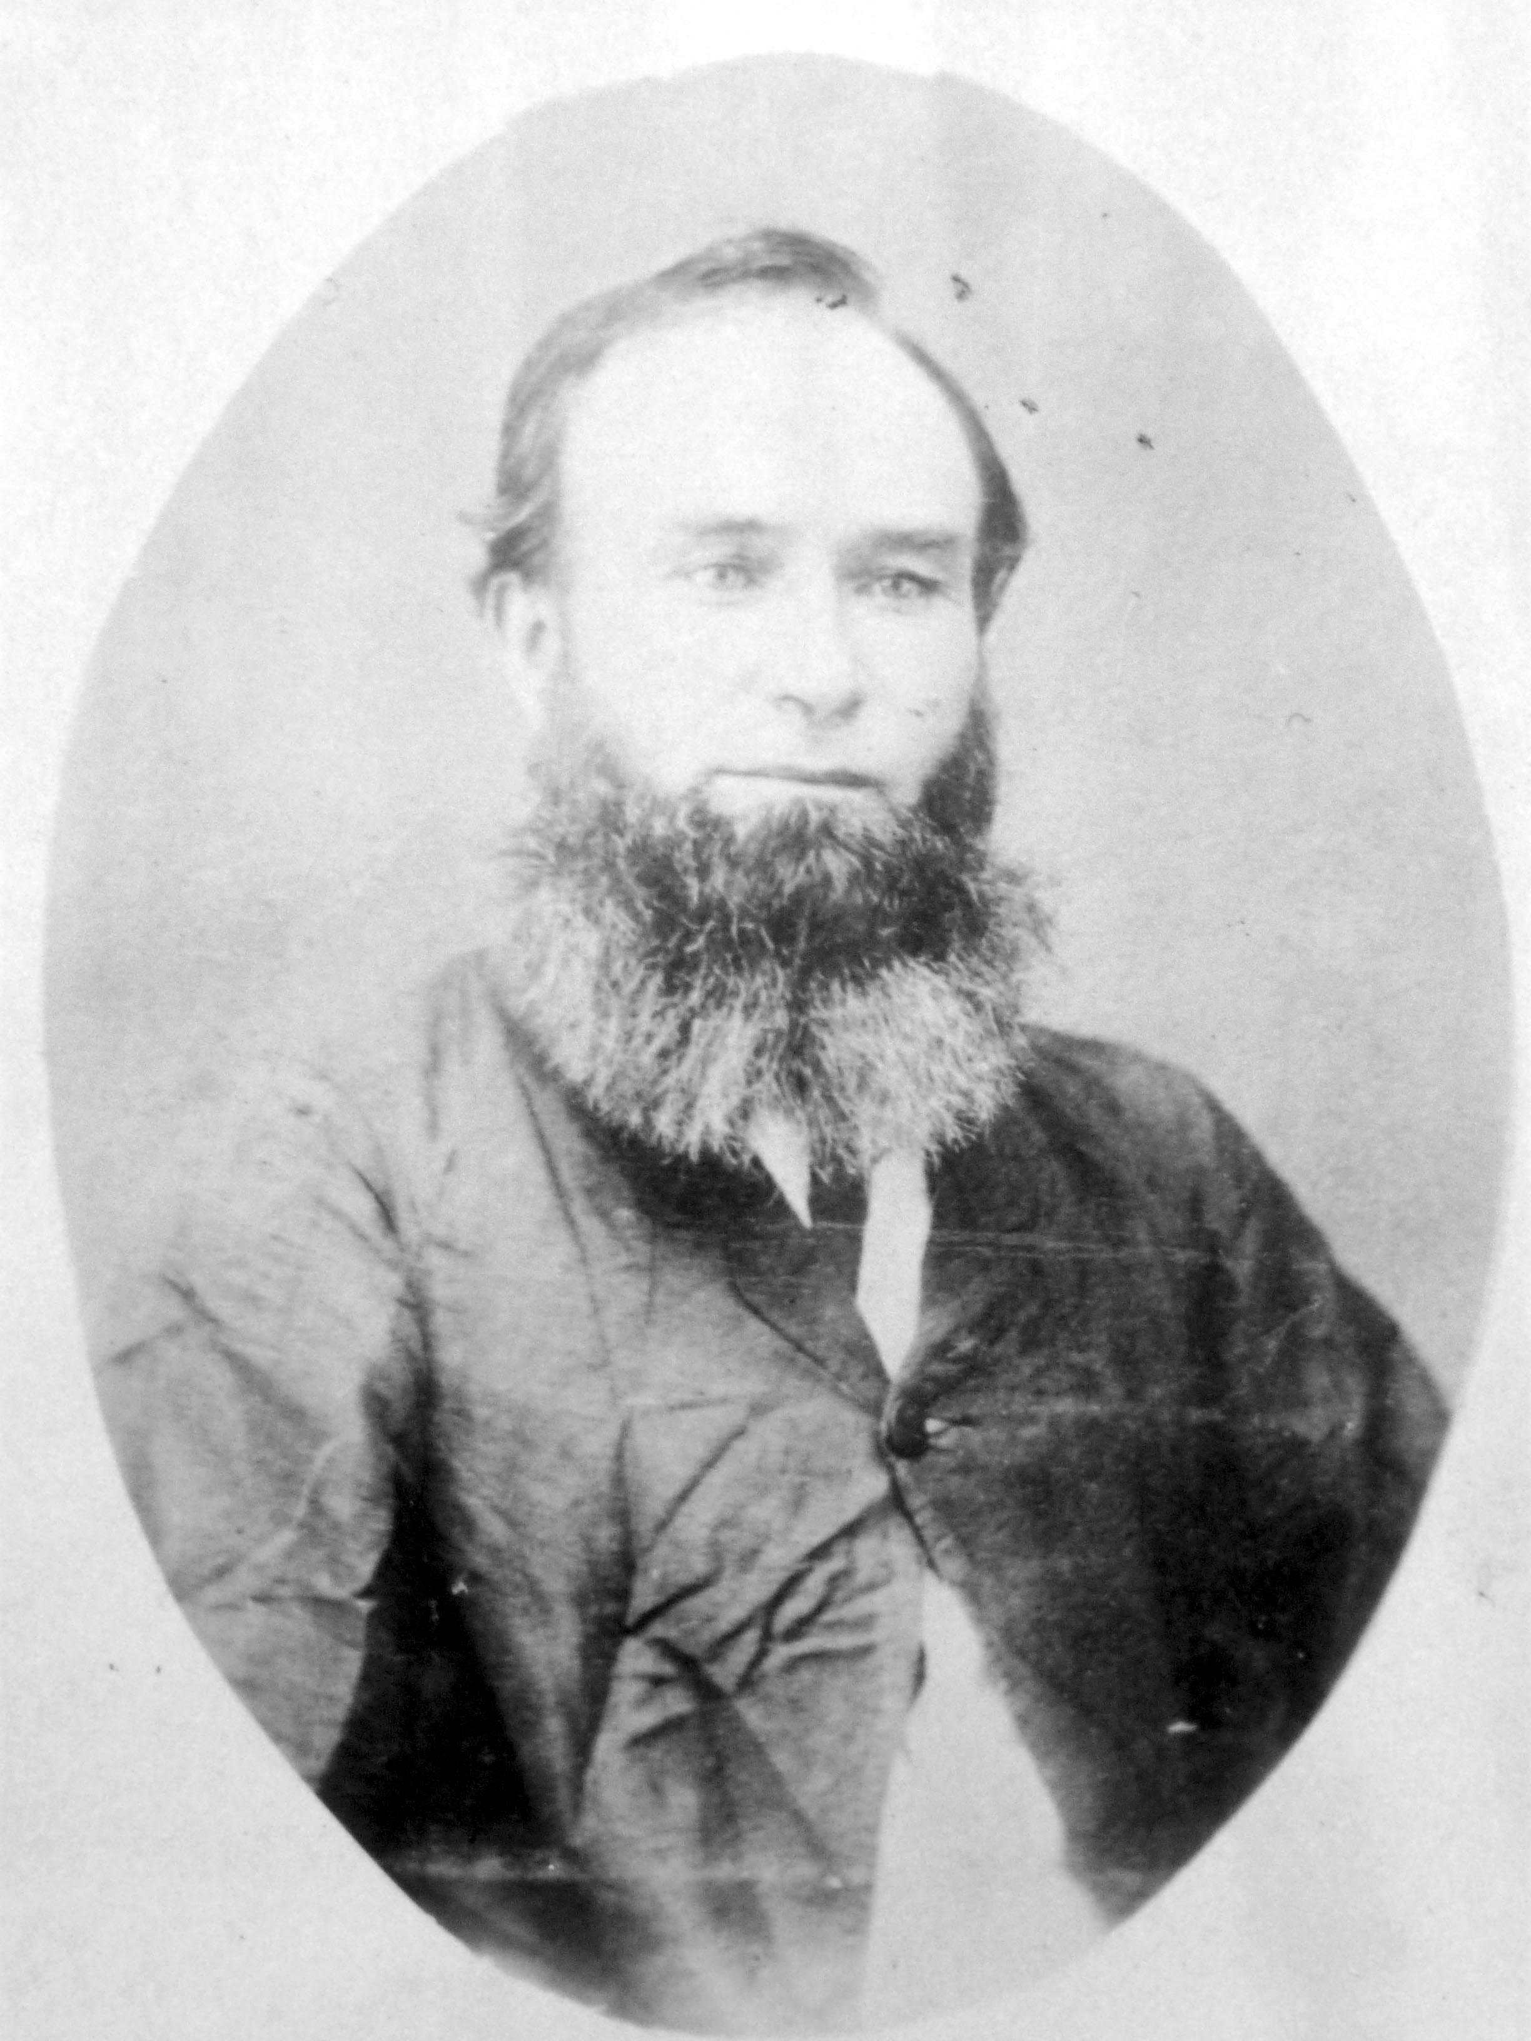
Our John Forsyth (pictured) was still in Bolong in 1864 when he married but from 1865-1867 he was employed on the clearing leases at Jaspers Brush just a bit further north. He may have been working closely with his father-in-law, Peter McLaren and his brothers-in-law, as his movements seem to follow theirs closely. From 1868 to 1871 he was working at Cambewarra, possibly on a property called “Willow Glen” where one of his sons was born, and then in 1872 he is once more documented as being at Bolong but his occupation is listed as ‘blacksmith’ – the first evidence we have that he had learned this skill from his father and intended to carry on the profession. It was probably fortuitous that he had this ability to supplement his income.

John and Jamesina had four children, James Imlay (5.10.1865), William Ernest (29.3.1868), John Patrick McLaren (31.5.1870) and May Comyn (9.5.1874).

A Mr Bernard Brown of Nowra who, amongst many other roles, was the local policeman and an auctioneer, was also a prolific diarist. He has left diaries covering 30 years listing community activities and snippets of information that are invaluable to us today in forming a picture of the society of Nowra and surrounds in the 19th century. Some relevant examples:

17 (February) Shrove Tuesday 1874

Mr Forsyth met this afternoon about Mrs Pattersons town allotment next to McLarens to put up a Smiths Shop. Title not…..

John is obviously preparing to move his blacksmith business into town. The Forsyths leased a house in Kinghorne Street, just up from his in-laws, the McLarens.

Tuesday 26th October, 1874

Mrs Forsyth and Miss McLaren out to tea with Anne.

Anne was Bernard Brown’s wife and she was obviously friends with Jamesina and her sister Mary McLaren.

Friday, 20 November, 1874

Mrs Forsyth, Mrs Alexander and Miss McLaren paid us a visit this afternoon, drank tea with us. Tom Harvey went by….into Forsyths for his Tinker Carriage.

Another afternoon tea but 3 sisters this time – Jamesina (McLaren Forsyth), Elizabeth (McLaren Alexander) and their sister Mary McLaren. John’s blacksmith shop is obviously up and running - on land owned by John Smith, according to the Rates Books, in the north-east corner of the central town block. Anne Brown died shortly after this visit.

Almost 12 months later:

Thursday12 August, 1875

Walked into PO this afternoon, poor John Forsyth got injured by the sledge hammer flying off the handle.

SHOALHAVEN NEWS SATURDAY AUGUST 14 1875

SERIOUS ACCIDENT: An accident befell Mr John Forsyth, blacksmith of Nowra, on Thursday last. It appears that while at work in the shop a 14 lbs hammer, used by the ‘striker’ flew from its handle and struck Forsyth in the lower part of the abdomen, inflicting serious injury. Dr Hooper was called in to attend upon the sufferer, and reports, up to last night, very favourably of the case.

Monday 16 August 1875

Heard that poor John Forsyth was dead, died at 5 o’clock this morning of the injury sustained by the coming off the sledge hammer from the handle.

SHOALHAVEN NEWS, AUGUST 18, 1875

Sad and Fatal Accident – In our last issue, we reported an accident which befell Mr John Forsyth, blacksmith of Nowra, by receiving the full force of a blow from the sledge hammer, which flew off its handle while being used by the striker, in the lower part of the abdomen; and stated on going to press that we were led to believe that no fatal results would ensue. We regret, however, to chronicle the death of Mr Forsyth in this issue, a change for the worse having taken place on Sunday evening last, from which he never rallied, and breathed his last about five on Monday morning last. The deceased, a very quiet and peaceably disposed man, was highly respected; he was an old resident of the district, and leaves a wife and several young children, as also a very large circle of friends to mourn their loss. About a month ago the deceased assured his life in the Mutual Provident Society for a sum of £200 having been passed by the medical referee as holding a first-class life, with every probability of living to a very good old age. His family, by this timely forethought, have been somewhat provided for. Here is an illustration for many heads of families to look upon, who, blessed with the best of health, still ignore one of the first injunctions of Holy Writ, by neglecting to provide for their old age, or their dependants.

The funeral of the late Mr Forsyth took place yesterday, and as may be expected, the procession was a very lengthy one, comprising all classes of the community.

Friday (September?) 1875 - Bernard Brown again:

Going into Nowra this afternoon to sell poor John Forsyths Blacksmiths tools.

Our ‘younger’ John Forsyth died on the 16th August, 1875, from ‘severe peritonitis caused by an accidental blow’. He was buried in the Worrigee Cemetery on the edge of Nowra. John was 44 years of age, Jamesina just 38, and she was left with 4 children aged 10, 7, 5 and 15 months. The baby, May, grew up without ever knowing her father. Much later in life she became grandmother to Michael and Jill.

At this stage we don’t know much about Jamesina’s life following the death of her husband. She stayed on in Nowra, at Greenhills, and the Nowra Rates Books (1876-1887) show that from 1877 Jamesina had a shop on James Graham’s land, probably with house attached, next door to her parents, Peter and May McLaren who had a house on 1 ½ acres of land. This would have been on Moss Street or Terara road which leads east along the river from Nowra to Terara. In 1879 there was a Mrs Forsyth listed as running a boarding house which seemed to be a common occupation for widowed women. The ‘shop’ disappears from the record from 1880 and from 1886 the McLarens and Forsyths were living together in a cottage on Mr Graham’s sub-division. The insurance money must have been a tremendous help to Jamesina in providing for the family.

The children were probably all schooled at the Nowra Public School, and up to High school level somewhere, as the boys went on to become professional people. The family bible is still in our possession and the fly leaf is signed, presumably by Jamesina, as ‘Nowra, 1880’. Not long after this the family had all moved to Sydney – in stages. Jamesina obviously had a plan for her young people to move away from a life of being labourers and mechanics and to take up the newer and more secure opportunities becoming available in the city.

[After 20 years in the Nowra area Aunt Helen Forsyth Patison and family had moved back to Sydney, prior to her nephew’s death, and lived in various places in Devonshire Street. Helen died on 8th December, 1879, at 232 Devonshire Street, Sydney, aged 84 years and was buried at Rookwood. Her grave is in the Presbyterian section: 4, Row 10, Grave 158. Also on the headstone are the deaths of 3 grandchildren who died in 1861, 74 and 76. Helen had been a widow for 41 years.]

City Life Again.

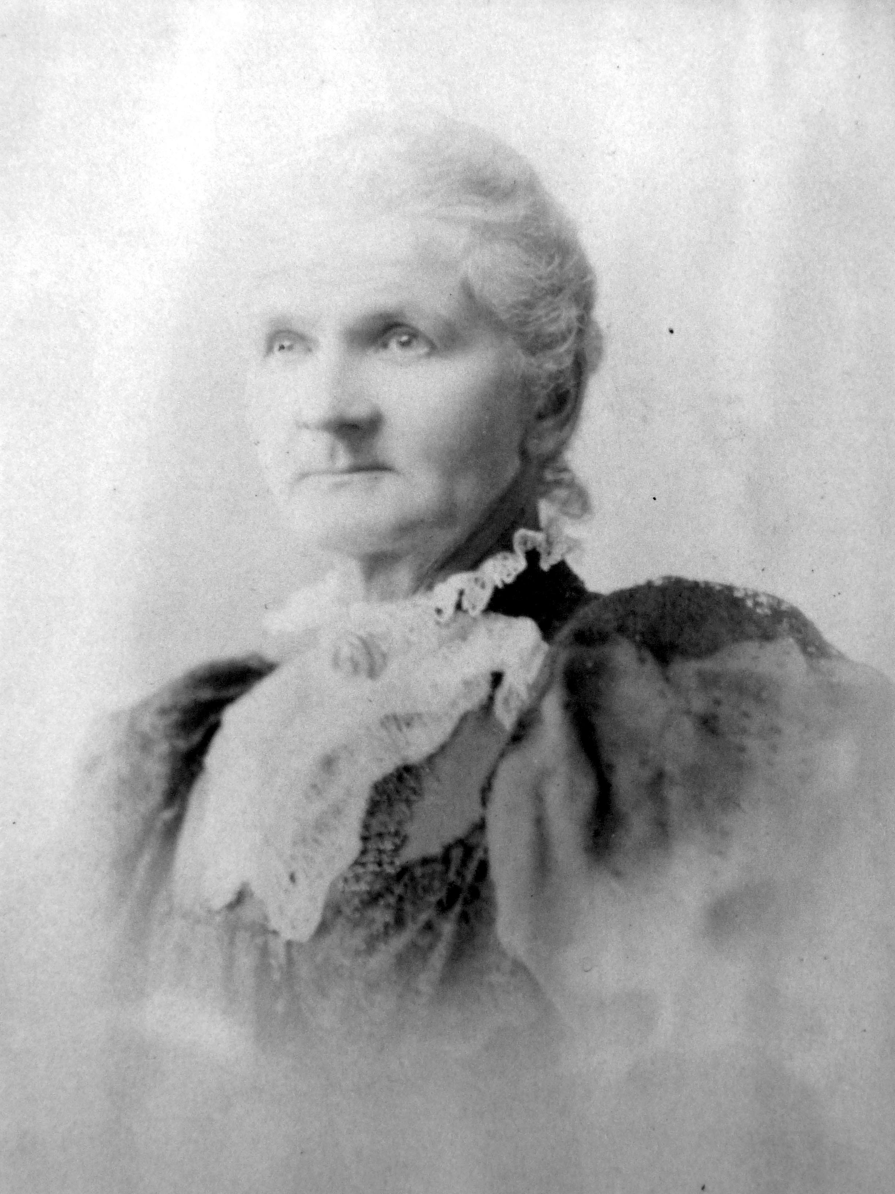
In the Sydney Sands Directory of 1892 there is a J. Forsyth listed as living at 15 Cambridge Street, Paddington, and William Ernest is there too so it could be Jamesina (pictured) or James Imlay. They are listed again in 1894 and 1895 when John Patrick McLaren Forsyth “Jack” is also included. In 1895 James Imlay was 30, Willie E was 27, “Jack” was 25 and May “Daisy” was 21. Jack had been in Sydney since at least 1884.

John and Jamesina’s daughter, May Forsyth, married James George McKee/MacKee in April, 1899. From at least 1903, Jamesina lived with her daughter and son-in-law at 140 Newland Street, Waverly, presumably helping with the care of her grandchildren.

Jamesina died in the “Scarness” Private Hospital, Ashley Street, Chatswood on the 17th January, 1928, aged 90 years. She was buried in the Waverley cemetery in the same grave as her unmarried sister, Mary McLaren, who had died in 1917. Jamesina had been a widow for 53 years.

John and Jamesina had had 3 sons to carry on the Forsyth name and despite her early widowhood Jamesina was able to educate them to, mostly, have successful lives in the Public Service.

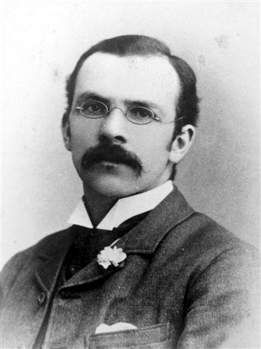
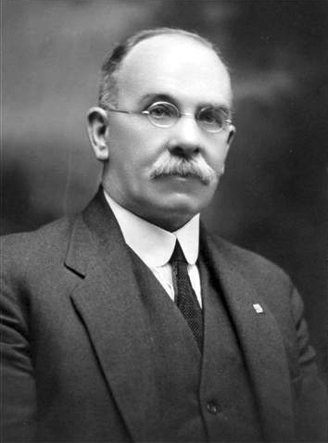
(James) Imlay Forsyth, born at Jasper's Brush in 1865, was trained as a teacher, was teaching by 1895 and in 1915 he was Headmaster at Beecroft Public School. In 1895 he had married Ann Jane Steel and they had 5 children, 3 daughters and 2 sons. In 1916 his 20 year old son, Robert, died at home with a cerebral tumour. He had been a student of Hawkesbury Agricultural College and was considered a ‘pig and bacon expert’. (He was the first of several members of the Forsyth/Mackee/Keys family to attend Hawkesbury College.) Imlay was Session Clerk at the Beecroft Presbyterian Church for 21 years and retired from teaching in the late 1920s. He died at his home “Glenorchy”, at 22 Miriam Road Ryde in 1937, and was buried at Waverley Cemetery.

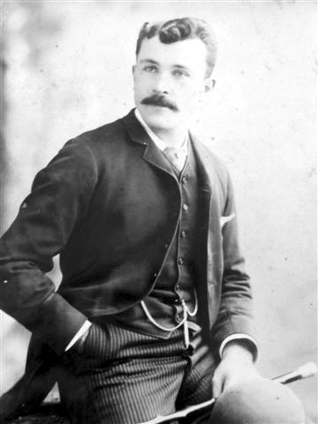
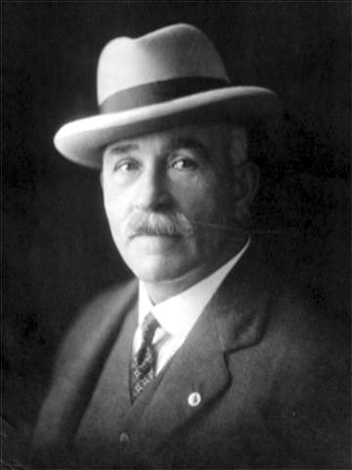
William Ernest, Willie, born at Camberwarra in 1868, was appointed a clerk at the Water Police Court in Sydney in 1892 at the age of 24. In 1895 he moved to the Deed’s Office of the Registrar-General’s Department as an ‘Additional Attendant’ and shortly after to the Audit Office as Examiner under the Old Age Pension’s Act. On February 9, 1903, he joined the staff of the Stamp Duties Office as a clerk, and after being an Assessor was appointed Commissioner in 1922. He was 11 years as Commissioner of Stamp Duties for NSW before he retired in 1933, after 41 years in the Public Service. In 1894 Willie had married Queenie Upton and they had 2 sons, Reginald and Leonard. Queenie died in 1934 and Willie died in 1939. He had been one of the original members of the Public Service Association, a founder of the Petersham Cricket Club and the Petersham Baseball Club and a member of the Beecroft Bowling Club. His death was marked with a special article in “The Sydney Morning Herald”. His home at 21 Welham Street, Beecroft, was named “Cambewarra”.

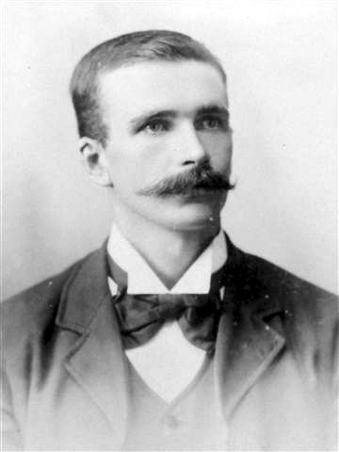
‘Jack’ Forsyth, born Cambewarra in 1870, was employed as a Telegraph Officer at the George Street North Post Office for 20 years from 1884 to 1904. Jack married Mary Thomas in 1894 and they had 1 son, John Lyle McLaren Forsyth, in 1895. Unfortunately, in 1904 Jack was charged with ‘stealing letters and removing stamps’ from the Post Office and was sentenced to 2 years in Darlinghurst Gaol. Jack had a daughter, Thelma, by Hilda Jackson in 1912, divorced Mary in 1913 and married Hilda in 1914. He died in 1925, aged 54, of pneumonia in The Coast Hospital, later renamed the Prince Henry Hospital, and was buried at the Randwick General Cemetery. His death certificate lists his occupation as ‘Traveller’ and neither Mary, Hilda or the children are listed in his newspaper death notice. His last residential address is that of his sister May and her husband, George MacKee in Waverley.

“Daisy” May, born in Nowra in 1874, spent her adult life as the wife of the very busy James George MacKee and she and her children will feature some more as part of “The McKee Story”. May was fully occupied as a mother and community member in the society of the time, and the wife of a Councillor amongst other roles. May, our direct line, and George had 4 children:

Ronald father to Don MacKee and Jean Bartholomew
Marjorie mother to Ken and Bruce Watson
Mavis mother to Peter Monaghan
Alison mother to Michael and Jill Keys.

May’s home at 140 Newland Street, Waverley, was also called “Glenorchy”.

Obviously Jamesina had achieved her aim of ‘improving’ the status of life for her children if that is what she intended to do. Maybe it was all coincidental but she must have had some pride in what she had achieved on her own.

We’ve learned at little of just 3 generations of Forsyths here in this story. So what remains of the Scottish heritage in this last generation of 20th century Australians that we have looked at? Probably the most obvious feature would be their abiding staunch Presbyterianism. But their sentimental attachment to the country of their forbears and the moralistic life designed there is gradually fading for us as we move further away in time from those days of emigration and adventure, and into the 21st century. Now, when international travel is readily available, it’s a popular idea to ‘go back’ and ‘see where our ancestors came from’ but inspiration is mostly to be found when we follow their journeys through their new adopted homeland.

Margaret Keys, 2010.

