**James Forsyth (1818 – 1907)**

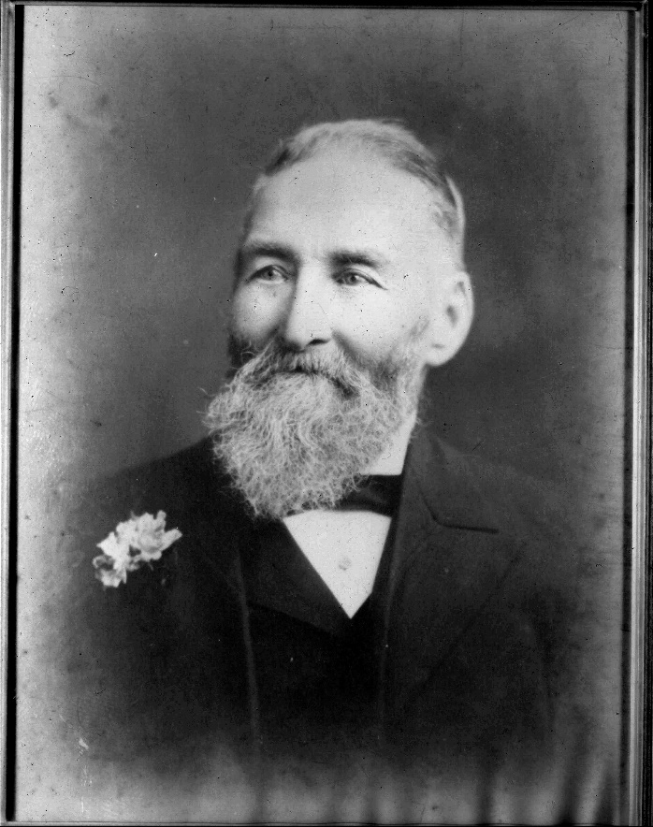

He resided for many years at Willoughby, and always took an active interest in all matters connected with the welfare of the district. He was closely identified with the growth of the Methodist Church in the northern suburbs, and his generous support enabled many efforts at church building to be carried out, both in Willoughby and North Sydney.

Master Tanner

Alderman Willoughby Council (1873-1881, mayor 1875)

Foundation member St Leonards Bowling Club (1888-1900)

James Forsyth was born in Bermondsey, London, but was raised in Newcastle upon Tyne. He became a leather tanner as was his father and worked in both Newcastle and Bermondsey. He married Margaret Todd in 1837. They lived in poor conditions in Bermondsey until James went looking for a better life, travelling as a mariner to the USA and Australia, where he joined the gold rushes. He eventually settled in Sydney and made enough money to summon Margaret and his family to join him. He then established the first tannery in Willoughby and also a leather goods shop on Broadway. He retired in 1883 handing the business over to his sons Thomas and Robert.

He served on Willoughby Council from 1873 until 1881, and was Mayor in 1875).

He was a sponsor and supporter of the Methodist churches at Mowbray Road/Pacific Hwy, Clanwilliam St Willoughby and North Sydney. He supported a Temperance Hall in Penshurst St. He donated land in North Sydney for a church.

James also donated land to enable widening of roads in Willoughby, and Forsyth St is named after him.

He was a foundation member of St Leonards (now North Sydney) Bowling Club.