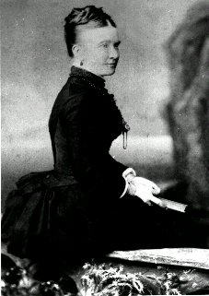

**Margaret Dorling Coulter**

**(1855- 1939, nee Forsyth)**

Margaret Forsyth was born in Bermondsey London, a poor working class industrial suburb where her brothers worked as tanners. The family migrated to Sydney in 1863, and lived near Broadway before moving to Willoughby near their tannery. She married George Coulter in 1874, and they had four children, three of whom survived infancy. They lived next door to Margaret’s parents James and Margaret at North Sydney, but separated not long after. Margaret tended her mother who was ill for several years and died in 1891. Her sister Sarah and husband had both died of TB in 1886 and 1887, and Margaret raised their son Tom at North Sydney with her own children, while also caring for her father James until his death in 1907.

Margaret did considerable voluntary work for the Methodist church, the Temperance Society, the Benevolent Society, and Royal North Shore Hospital.