**Margaret Patricia SNODGRASS**, **OAM**

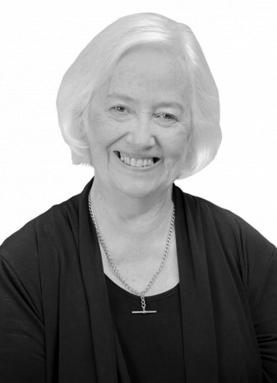

**Order of Australia in 2014 for service to the community of Willoughby.**

**Citizen of the Year, Willoughby City Council, 2009.**

**Families and Friends of the First Australian Imperial Force, Committee Member, since 2005; Commemorations Officer, since 2010; Foundation Member, 2002.**

**Chatswood Sub-Branch, RSL, Volunteer and Inaugural Affiliate Member,**

**North Shore Ryde Health Service Community, Willoughby Council’s rep.**

**Royal North Shore Hospital, Participation Committee, 2007-2012.**

**Willoughby Historical Society Volunteer.**

**Willoughby Uniting Church; benefactor and organiser of regular social events for the elderly, and donated funds for memorial church windows.**

**Fundraiser, various local organisations including St Thomas' School, Willoughby Public School, Family Cancer Council New South Wales, local emergency services; in conjunction with Mrs Snodgrass’ family business.**

**Inner Wheel Club of North Sydney; Past President, current Committee Member.**

**Justice of the Peace**

**Northern Suburbs Netball Association; a Patron and Awards Day Sponsor,**

**for over 20 years; sponsorship inaugurated by Mrs Snodgrass’ father and brother over 40 years ago.**

**Chatswood and Willoughby Bowling Clubs, Competition Sponsor, for**

**over 20 years; in conjunction with Mrs Snodgrass’ family business.**

**Director Forsyth Real Estate**