**SNAPPER ISLAND**

**Natural features**

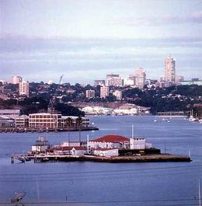**Snapper Island, like Cockatoo Island, is part of the series of drowned knolls along the ridges between the flooded river valleys of the Parramatta and Lane Cove Rivers.**

It is the smallest island in the harbour and probably more than most of the others it has been reshaped significantly by human intervention.

The island has been flattened and formed roughly into the shape of a ship with longer sides oriented to the northwest and southeast.

There is little evidence of its natural form and are no remains of the original vegetation.

Two Cabbage Tree palms planted in the 1930s are a local landmark.

There are no known threatened flora or fauna species on the island.

**History of the site**

*1879-1910s: A Public Recreation Reserve*

In late 1878, the NSW Legislative Assembly resolved that some harbour land should be set aside for public use, because wealthy private individuals were acquiring more and more of the foreshores.

So in 1879, Snapper Island (along with Rodd Island and Clark Island) were declared public recreation reserves, however Snapper Island remained a rarely visited rocky outcrop.

*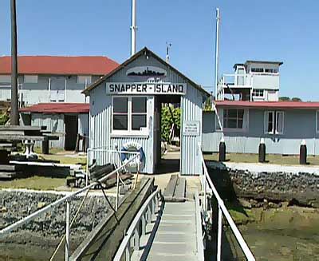Snapper Island is off-bounds to the public at present*

*1913-1930: Storage for Cockatoo Island*

When nearby Cockatoo Island was passed to the Royal Australian Navy in 1913, Snapper Island was included in its 'naval waters', and as such subject to naval control.

During World War I the island was leased to the Cockatoo Island Dockyard for storing ships' parts and old corrugated iron.

*1931-1942: A Training Facility under Leonard E. Forsythe*

In 1930, Leonard E. Forsythe was able to persuade the Commonwealth Government to lease him the island at a peppercorn rental of £15 per year. His vision for the island was to create a training depot for boys in nautical skills. The name given to the new facility was the *Sydney* Training Depot - named as a memorial to the famous Australian cruiser which had sunk the German raider *Emden* during World War I.

Around 50 cadets (known as the *Navy Sea League Cadets*) were recruited and began work on the island. After clearance of the lantana-dominated vegetation that covered the island in 1931, the island was flattened by blasting an estimated 1,000 tonnes of rock from the top of the island over an eight month period. Associated land reclamation activities increased the size of the island by around 1,000 square metres.

The stone sea walls of the island were sculptured to create the shape of a ship with a bow (pointing towards Drummoyne) and a stern (pointing towards Cockatoo Island).

In 1932 building work commenced on a signal station, wharf and the other main buildings that can be seen today. The layout of these buildings models the layout of a naval ship. The cadets also planted the two cabbage-tree palms, which are still the only vegetation left on the island.

Training provided on the island was broad and varied, including rowing, sailing, seamanship, boat maintenance, signalling and rope work, rigging, radio operations, first aid, cooking and marksmanship.

*1942-1950s: War Reclaims the Island*

*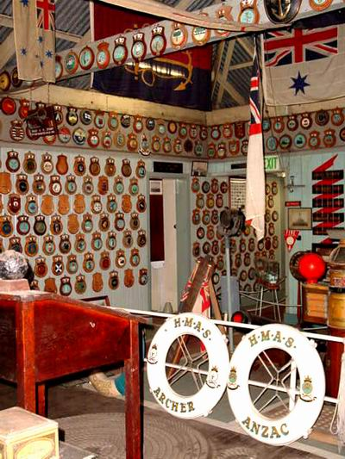Naval memorabilia on Snapper Island*

As part of the original lease, Snapper Island was to revert to the armed services if necessary, and with the onset of World War II, Len Forsythe offered the island and the use of his cadets to the Navy.

This was accepted and the cadets spent many hours ferrying Navy personnel to and from their posts.

At the end of 1942 United States troops moved onto the island to use it for training purposes. The British also used some of the facilities on Snapper Island as a social club for troops on leave.

*1952-1960: A Museum*

In 1952, Forsythe decided to set up a museum on Snapper Island, the income from which would go towards the ongoing maintenance of the island. The museum held thousands of pieces of memorabilia from Australia's naval history.

The museum was ready to open by 1960.

Forsythe set up the Snapper Island Company, made up of ex-cadets and cadets, to keep the island and its facilities going.

*1960s-Today: Snapper Island Today*

Len Forsythe died in 1983 at the age of 91. His funeral, at Garden Island Chapel, overflowed with many family, friends and ex-cadets.

New regulations came into effect in 1985 governing the storage of explosives on nearby Spectacle Island, which brought the future of Snapper Island into doubt.

After several years of uncertainty, the Snapper Island Company managed to persuade the Commonwealth Government that they could stay on the island, due to safety concerns about explosives on Spectacle Island no longer being a problem.

There are no cadets following training programs on the island today, and the Harbour Trust has been charged with developing a management plan for the future of the island.

*NB: Much of the historical information on Snapper Island is taken from the book: "The Islands of Sydney Harbour" by Mary Shelley Clark and Jack Clark (2000).*

------------------------------------------------------------------------------------------------------------------------------------

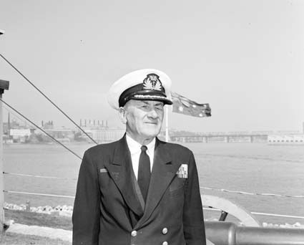

Leonard Edgar Forsyth 1960

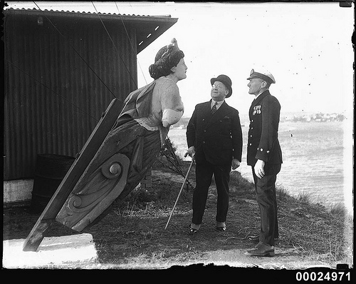

Sir Robert Archdale Parkhill inspects a ship's figurehead at Snapper Island, Sydney

This photograph depicts Federal Minister for Defence Sir Robert Archdale Parkhill (in a bowler hat), inspecting a ship's figurehead at Snapper Island in Sydney on 20 July 1935. Minister Parkhill presented badges to the cadets for their part in building the depot as a national memorial to HMAS SYDNEY I, which had been decommissioned in 1928 and scrapped in 1932. The figurehead came from the iron bark GWRTHEYRN CASTLE, built 1876. This ship was acquired by Scott Fell in 1922 and converted to use as a coal hulk in Sydney in 1923. It was still in use in 1929. The figurehead was part of the **Leonard E Forsythe** Collection displayed at the Sydney Training Depot on Snapper Island. Australian examples of ship's figureheads and bow decorations are extremely rare, and in 2008, the ANMM acquired the figurehead as [part of the National Maritime Collection](http://emuseum.anmm.gov.au/code/emuseum.asp?style=browse&currentrecord=1&page=search&profile=objects&searchdesc=00047422&searchstring=ANMMQuickSearch/,/contains/,/00047422/,/false/,/true&newvalues=1&newstyle=single&newcurrentrecord=1).

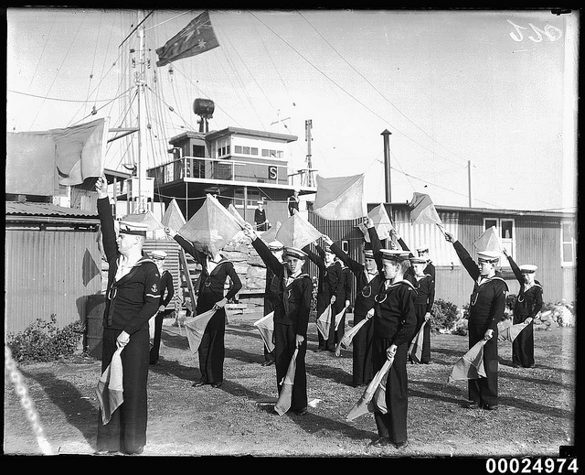

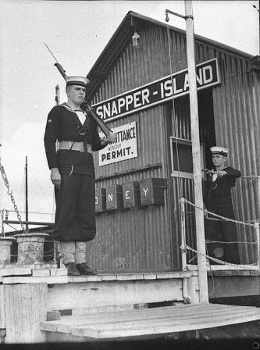

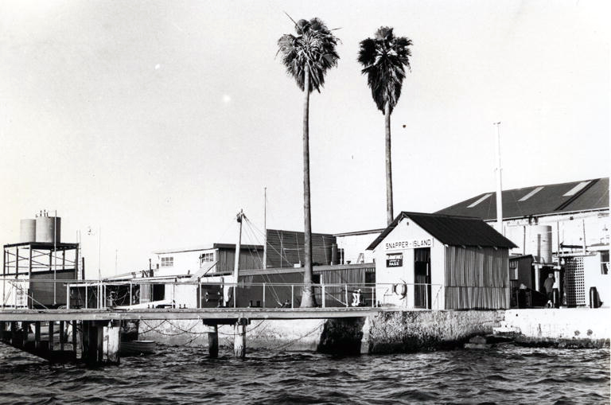

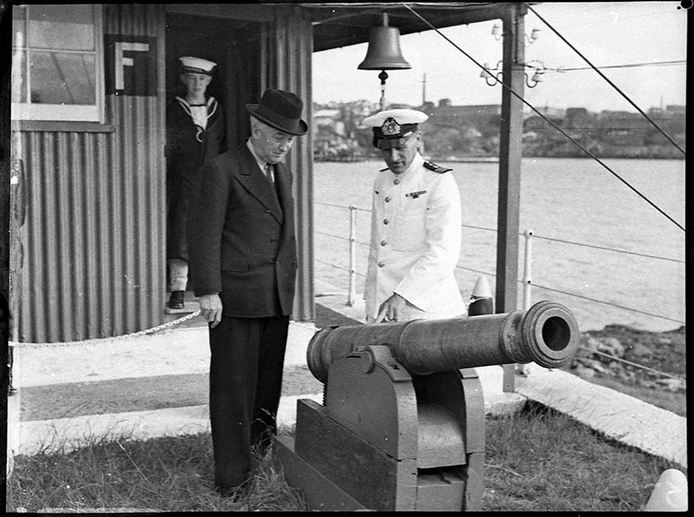

*Commanding Officer Leonard E Forsythe and Prime Minister Joseph Lyons at the opening of the Navy League's Sydney Training Depot on Snapper Island 26 November 1938*





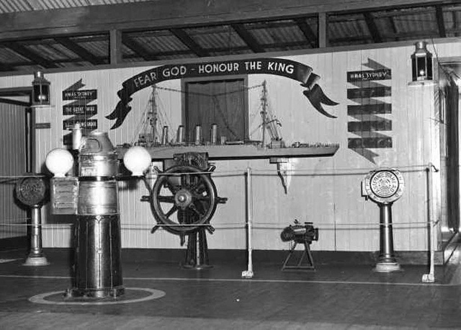

*Circa 1950s: Model and relics of HMAS SYDNEY [I] at Snapper Island Museum, Sydney - Samuel J. Hood [1872-1953], SLV*

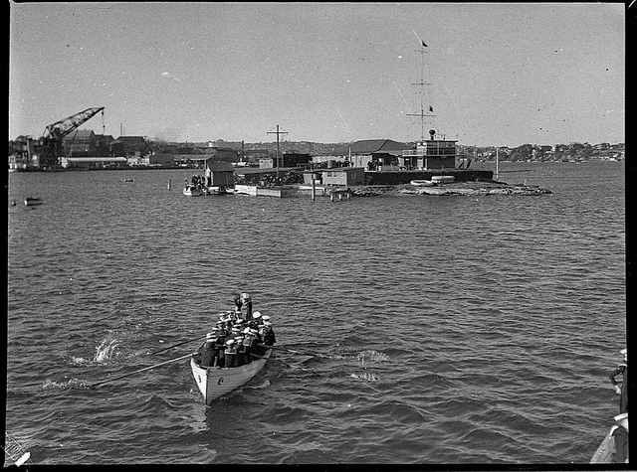

*1938: Naval cadets depart Snapper Island in Sydney - Samuel J. Hood* [1872-1953] SLNSW.

2713. The 1.65 hectare [about 6 acres] Snapper Island is the smallest in Sydney Harbour, not much than a earth-covered rock increased by levelling and landfill.

Sited just west of the Cockatoo island dockyard [seen left] it was the site for many years of a nautical training school for boys, the Navy Sea League Cadets. An initiative by a gentleman named Leonard E. Forsythe, the boys gradually transformed the island and its installations into the form of a ship.

Coming under naval control just before WWII Snapper Island was used to accommodate both American and British service personnel during the war, possibly people connected with the repair of Allied ships being carried out at Cockatoo. By that time also the site of a naval signalling station, shown in the photo above.

In 1960 a museum was established on the tiny island, with many naval artefacts, photographs and records held there, the core of the collection being items salvaged from the famous WWI cruiser HMAS Sydney [I} when she was being scrapped across at Cockatoo.

Sadly, the Museum now appears to be closed. The island's website says it [the island] is presently closed to the public.

Photo: Samuel J. Hood [1872-1953],

**Snapper Island**

by [Catie Gilchrist](http://dictionaryofsydney.org/contributor/catie_gilchrist), 2014  
supported by [Maritime Museums of Australia Project Support Scheme](http://dictionaryofsydney.org/contributor/maritime_museums_of_australia_project_support_scheme) [Cite this](http://dictionaryofsydney.org/citation/105295)

**Snapper Island**

**Catie Gilchrist**

Tiny Snapper Island is the smallest island in Sydney Harbour. It lies 200 metres off [Drummoyne,](http://dictionaryofsydney.org/place/drummoyne) close to [Spectacle](http://dictionaryofsydney.org/natural_feature/spectacle_island) and [Cockatoo](http://dictionaryofsydney.org/natural_feature/cockatoo_island) islands. Locals have variously called it Flea, Rat or Mosquito Island, names which suggest its lack of appeal or usefulness. Indeed, in May 1891, [*The Sydney*](http://dictionaryofsydney.org/artefact/sydney_morning_herald) [*Morning*](http://dictionaryofsydney.org/artefact/sydney_morning_herald) [*Herald*](http://dictionaryofsydney.org/artefact/sydney_morning_herald) published an article entitled 'Among the Islands'. Of Snapper Island, the writer disparagingly noted

its only office is to supply standing room for sea fowl – some place where they can meet and deliberate unmolested. [[1]](http://dictionaryofsydney.org/entry/snapper_island)

Snapper Island had been declared a public recreation reserve in 1879 but it remained a rarely visited, rocky and rat-infested outcrop. By the 1930s, however, this tiny isolated speck at the mouth of the [Parramatta River](http://dictionaryofsydney.org/natural_feature/parramatta_river) had been completely transformed; flattened, enlarged, reshaped and turned into a voluntary and very popular sea training establishment.

**Sea Cadet training island**

In 1921 [Leonard E Forsythe](http://dictionaryofsydney.org/person/forsythe_leonard_edgar) was involved with the founding of the [Navy League Sea Cadet Company](http://dictionaryofsydney.org/organisation/navy_league_sea_cadet_company) at Drummoyne. By 1929 over 70 boys were enrolled and new premises were necessary. Forsythe leased Snapper Island from the government, determined that this little island was the perfect place to train boys in nautical skills. He also wished to establish the island as a national memorial to [*HMAS Sydney*,](http://dictionaryofsydney.org/artefact/hmas_sydney_i) which had been decommissioned in 1928. Four years later, *HMAS* *Sydney* was broken up on nearby Cockatoo Island and the unit paid £30 for many parts of the old ship; these salvaged objects became the basis of the new Training Depot. [[2]](http://dictionaryofsydney.org/entry/snapper_island)

Between 1931 and 1932 Forsythe and many of his cadets flattened and expanded the island by blasting more than 1000 tonnes of rock from the top of the island to make a flat surface. The rock was then used to build up land reclaimed from the sea, thus increasing the area of the island by one-third. [[3]](http://dictionaryofsydney.org/entry/snapper_island) A sea wall was built from the rock with a total length of 279 feet, (85 metres), eight feet (204 metres) high and five feet (1.5 metres) in thickness. It was sculptured so that it shaped the island like a ship, 'the bow towards Drummoyne, and the stern towards Cockatoo Island.' [[4]](http://dictionaryofsydney.org/entry/snapper_island) The buildings, accommodation and training facilities built on the island were designed along the lines of a ship of war so that the cadets would be quite at home when afloat. The boys also built a wharf and planted two cabbage-tree palms 'which are still the only trees on the island.' [[5]](http://dictionaryofsydney.org/entry/snapper_island)

By 1937 the cadets numbered 110, with 75 on the waiting list. There were three divisions: the Boys' Division for boys aged 10 to 13, the Cadet Division for boys 14 to 15 years of age, and the Seamen Division for young men from 16 years. In 1945 a fourth division was added when girls aged 14 years and upwards were invited to join; by December 1946 35 girls had become regular volunteers. [[6]](http://dictionaryofsydney.org/entry/snapper_island) They received the same training as the boys but were not expected to perform very heavy work. The training given to these youths on Snapper Island was indeed vigorous and provided experience in all matters of seamanship; rowing, sailing, boat maintenance, rope work and signalling. First aid, cooking, radio operation and marksmanship were also taught. Beyond these skills, physical fitness was central to the cadet program, with boxing and gymnasium classes held on Friday nights. For many of the youthful cadets the skills and training, together with the discipline and the drill of Snapper Island, would give them a clear insight into their future careers. In 1940 more than 200 boys trained at the establishment had been accepted by the Royal Australian Navy, while others had obtained employment with civil aviation companies. [[7]](http://dictionaryofsydney.org/entry/snapper_island) By 1945, 2,200 youths had completed courses in seamanship, boat handling and signalling; of these, 700 went on to join the Navy. [[8]](http://dictionaryofsydney.org/entry/snapper_island)

During World War II the island was used as a training and recreational area for Australian, American and British armed forces. An 'excellent club room and reading room' was opened for the troops based there in May 1944 with the financial help of the [King George Fund for Sailors.](http://dictionaryofsydney.org/organisation/king_georges_fund_for_sailors) [[9]](http://dictionaryofsydney.org/entry/snapper_island) In 1960 Forsythe opened a museum of artefacts and curiosities from Australia's naval history on the island; he also formed the [Snapper Island Company,](http://dictionaryofsydney.org/organisation/snapper_island_company) made up of cadets and ex-cadets. This company continues to lease the island from the Commonwealth Government. Snapper Island is currently closed to the public.

**References**

Mary Shelley Clark and Jack Clark, *The* *Islands* *of* *Sydney* *Harbour*, Kangaroo Press, Sydney, 2000

**Notes**

[[1]](http://dictionaryofsydney.org/entry/snapper_island) 'Vaurien', 'Among the Islands', The Sydney Morning Herald, Saturday 23 May 1891, p 4

[[2]](http://dictionaryofsydney.org/entry/snapper_island) G Blaxell, The River; Sydney Cove to Parramatta, Brush Farm Historical Society, NSW, 2004, p 50

[[3]](http://dictionaryofsydney.org/entry/snapper_island) BG Matthews, 'Snapper Island, A Saga of Self-Help', The Sydney Morning Herald, 10 July 1940, p 7

[[4]](http://dictionaryofsydney.org/entry/snapper_island) Mary Shelley Clark and Jack Clark, The Islands of Sydney Harbour, Kangaroo Press, Sydney, 2000, p 158

[[5]](http://dictionaryofsydney.org/entry/snapper_island) Mary Shelley Clark and Jack Clark, The Islands of Sydney Harbour, Kangaroo Press, Sydney, 2000, p 158

[[6]](http://dictionaryofsydney.org/entry/snapper_island) 'Sea Cadet Corps at Snapper Island', The Sydney Morning Herald, 18 December 1946, p 15

[[7]](http://dictionaryofsydney.org/entry/snapper_island) 'Old Captain Cook to be Training Ship', The Sydney Morning Herald, 9 February 1940, p 5

[[8]](http://dictionaryofsydney.org/entry/snapper_island) 'Sea Trainees at Snapper Island', The Sydney Morning Herald, 9 February 1945, p 5

[[9]](http://dictionaryofsydney.org/entry/snapper_island) 'Clubroom for Army Sailors', The Sydney Morning Herald, 20 May 1944, p 4

http://www.heritage.gov.au/ahpi/images/title.gif

**[** [**New Search**](http://www.heritage.gov.au/ahpi/index.html) **]**

|  |  |  |  |  |  |  |  |  |  |  |  |  |  |  |  |  |  |
| --- | --- | --- | --- | --- | --- | --- | --- | --- | --- | --- | --- | --- | --- | --- | --- | --- | --- |
| --- | Snapper Island  |  |  | | --- | --- | | **Source:** | Go to the [Commonwealth Heritage List](http://www.environment.gov.au/cgi-bin/ahdb/search.pl?mode=place_detail;place_id=105477) for more information. | | **Identifier:** | 105477 | | **Location:** | Drummoyne | | **Local Government:** | Canada Bay City | | **State:** | NSW | | **Country:** | Australia | | **Statement of Significance:** | Snapper Island, comprising the original sandstone area, fore and aft areas of made ground, a range of utilitarian buildings and maritime structures, is historically important as the primary expression of the Navy League UK, established at Drummoyne in 1921 by Len Forsythe, who saw the need to establish a voluntary training scheme for young boys, as naval cadets. The Sea Cadet movement is believed to be one of the oldest youth movements in the English speaking world.  The Snapper Island facility was officially opened on 26 November 1932 by Sir Charles Cox, on behalf of the Minister for Defence, as a living memorial to HMAS Sydney. HMAS Sydney, the first Royal Australian Navy ship to sink an enemy warship, the Emden, had been an inspiration to Forsythe. Snapper Island was the headquarters of Sydney's naval cadet groups and the Navy League from 1932 to 1977, and as such provided a voluntary step towards recruitment in the Australian Navy.  (Criterion A.4)  (Historic Themes: 6.3 Training people for the workplace, 7.7 Defending Australia, 8.9 Commemorating significant events)   Snapper Island is of exceptional interest as a privately initiated and seminal naval cadet training facility, as the earliest surviving Navy League training depot in NSW and for its ship-like planning and layout. (Criterion D.2)   The Snapper Island training facility is recognised for its contribution to the landscape values of Sydney Harbour.  (Criterion E.1)   Snapper Island is highly valued by Sydney's naval cadet groups and the local communities for its symbolic, cultural, educational and social associations.  (Criterion G.1)   Snapper Island is closely associated with Len Forsythe, founder of the Navy League in Australia, and the driving force behind the development of Snapper Island as the focus of naval cadet training in Sydney.  (Criterion H.1) | | **Description:** | Snapper Island is a 1.65-hectare island at the mouth of the Parramatta River located approximately 300 metres north-east of Birkenhead Point, Drummoyne and oriented in a north-east/south-west direction. Cockatoo Island lies to the north-cast and Spectacle Island to the north-west.  The building platform is retained in part by rubble stone walls and in part by concrete sea walls. On the south-eastern side the original foreshore outcrops survive to form part of the side of the ship shaped island below the Mess Deck Starboard Classroom and between buildings 9 and 10, the J Payne Memorial Building and Main Deck Museum. The upper level of the island includes the Port Waist and Rifle Range, the Quarterdeck and the site of the Main Deck which define the original island areas. The lower level includes the Forecastle Deck, After End and the sites of buildings 3-6, 7-9 and 14. The Port Waist and part of the Quarterdeck are cement paved in common with areas between buildings 9-10. Capstan Flat comprises lawn and concrete pathways.   The island was planned to reflect the layout of ships at sea, the Main Deck building flanked by Port and Starboard Waists with Quarter Deck and After End at the stern and the Forecastle Deck at the prow. The Officers Accommodation is clearly separated from other ranks and closely associated with the Signal Station and Quarterdeck towards the stern. The Port and Starboard wharves (Items 1, 15), which provide access, are of timber construction as is the slatted boat Whaler ramp adjacent to building 6 (the Boatshed, Workshop and Store) and a number of walkways. The Baths and Tidal pools have collapsed. The main approach to the island on the north western side is identified by the two cabbage tree palms planted in the 1930s and the Officers accommodation. Buildings, which define the islands naval superstructure, and illustrate its cadet and museum roles, include the following.   Guard House (Item 2)  Officers Wardroom Mess (3)  Generator Room (4)  Mens and Womens Toilet Blocks (5, 7)  Boat Shed, Workshop and Store (6)  Gymnasium (8)  J Payne Memorial Building (9)  Main Deck-Museum (10)  Mess Deck-Starboard Classroom (11)  Signal Station (12)  Officers Cottage (14)  Flammable Store (16)   These main buildings which define the ship-like planning and layout are predominantly corrugated galvanised iron and timber, with a combination of hipped and skillion roof forms. A signal mast adds to the maritime character.   Other features illustrating the training role of the island include boat davits, a capstan, derricks, bollards and winches and signal masts. Other site features include a range of functional items from shipping, a memorial to Captain Bligh, cannon, anchors, a steam engine, naval field guns, gun barrels from Hood, Repulse and Renown, and the 1932 foundation stone laid by Miss Charles Fairfax on 21 May 1932. The island also contains a number of individual items of note including the original Austral petrol driven electric generator of 1931.   A small area of the original rock outcrops of the island remain which may contain archaeological evidence of former uses. | |